Question 1
Q. : What are React hooks? How do useState()and useEffect()hooks work in functional components?
Ans : React Hooks:
- Hooks Are Special Functions That Let You “Hook Into” React Features In Functional Components Without Using Class Components.
- Introduced In React 16.8.
useState():
- Manages State Inside Functional Components.
- Returns An Array With Two Elements: Current State Value And A Function To Update It.
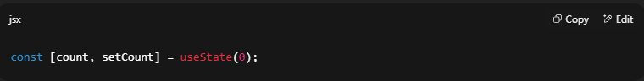
useEffect():
- Handles Side Effects (e.g., Fetching Data, Updating DOM, Setting Timers).
- Runs After Every Render By Default.
- Can Be Controlled Using A Dependency Array.
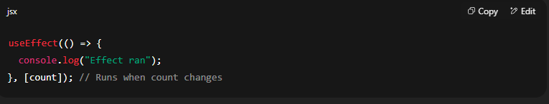
Question 2
Q. : What problems did hooks solve in React development? Why are hooks considered an important addition to React?
Ans : Problems Solved By Hooks:
- Avoided The Need To Convert Functional Components To Class Components To Use State Or Lifecycle Methods.
- Reduced Code Duplication By Allowing Reusable Logic Through Custom Hooks.
- Removed The Complexity Of this Binding In Class Components.
Importance:
- Hooks Make Functional Components Powerful Enough To Replace Most Class Components.
- Improve Code Readability And Maintainability.
- Enable Sharing Of Stateful Logic Without Changing Component Structure.

Question 3
Q. : What is useReducer ? How we use in react app?
Ans :
- useReducer Is A Hook Used For Complex State Management.
- Works Similar To redux Reducers But Inside A Component.
- Takes A Reducer Function And An Initial State, Returns Current State And Dispatch Function.
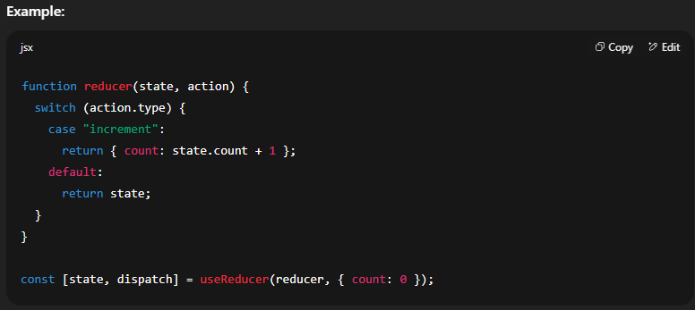
Question 4
Q. : What is the purpose of useCallback & useMemo Hooks?
Ans : useCallback:
- Memoizes A Function, Preventing It From Being Recreated On Every Render.
- Useful When Passing Functions To Child Components To Avoid Unnecessary Re-renders.
useMemo:
- Memoizes The Result Of A Computation, Only Recomputing When Dependencies Change.
- Useful For Performance Optimization In Expensive Calculations.
Question 5

Q. : What’s the Difference between the useCallback & useMemo Hooks?
Ans :
Feature | useCallback | useMemo
Returns | A Memoized Function | A Memoized Value
Usage | Prevents Function Re-creation | Prevents Expensive Re-calculations
Example | useCallback(fn, [deps]) | useMemo(() => computeValue(), [deps])

Question 6
Q. : What is useRef ? How to work in react app?
Ans :
- useRef Is A Hook That Creates A Mutable Object Which Persists Across Renders.
- Commonly Used To Access DOM Elements Directly Or Store Mutable Values Without Triggering A Re-render.
